Goonhavern Primary School- Design Technology
TOPIC: DT | YEAR: 5 | STRAND: Textiles

What should I know already? | What will I know by the end of the unit?
- A sock puppet is made out of sock and can be used using your hand  - There are different types of materials  - Scissors need to be used carefully especially in a busy classroom  - Some materials are harder to cut  - I can use a template to help me with my design  - I know how to create a simple stitch using a needle and thread  - How to create a running stitch  - How to use a pattern for my design | Design  - A design needs to be backed up by research and fit for its purpose  - I can choose a design based on its ability to meet its purpose:  - Who will use it?  - How will I attract younger children to my design?  - A pattern is the template from which the parts of a garment are traced onto fabric before being cut out and assembled.  - Patterns are usually made of paper, and are sometimes made of sturdier materials like paperboard or cardboard if they need to be more robust to withstand repeated use.  Make  - Scissors can be used to cut fabric and sharper scissors may be needed for thicker/more rigid materials  - A pattern needs to be used during the making stage to ensure both mittens are the same size and shape.  - Stitching will need to be done on the inside of my design  Evaluate  I could make my quiet book better by:  - Using a different material  - Using a stronger material  - Making it stronger by using more stitches or tying it tighter  - Stitching closer together to ensure no gaps  - There are many quiet books already made, how does mine compare? How could I improve mine?  Technical knowledge  - Sewing is stitching cloth, leather, furs, or other materials, using a needle and thread.  - Sewing can be done on a sewing machine, or by hand.  - "Plain" sewing is mostly done to make or mend clothing and household furnishings such as curtains, sheets, upholstery, and table linens.  - Backstitch - sturdy hand stitch for seams and decoration.  - Running stitch is a simple needlework stitch consisting of a line of small even stitches which run back and forth through the cloth without overlapping.
School Values
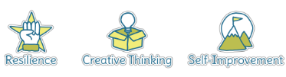

Five Ways to Wellbeing
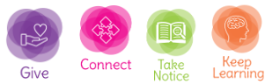

Vocabulary
Fabric | A cloth material
Felt | A thick and soft fabric
Rigid | Does not easily move/mould/cut
Design | a plan or drawing produced to show the look and function or workings of a building, garment, or other object before it is made.
Template | a shaped piece of rigid material used as a pattern for processes such as cutting out, shaping, or drilling
Model | a thing used as an example to follow or imitate
Textiles | A type of cloth or woven fabric
Sewing | The action that joins together
Needle | a very fine slender piece of polished metal with a point at one end and a hole or eye for thread at the other, used in sewing.
Thread | a long, thin strand of cotton, nylon, or other fibres used in sewing or weaving.
Running stitch | a simple needlework stitch consisting of a line of small even stitches which run back and forth through the cloth without overlapping.
Quiet book | a picture book made from fabric

Image/diagram that helps me to articulate my knowledge/understanding | Investigate!
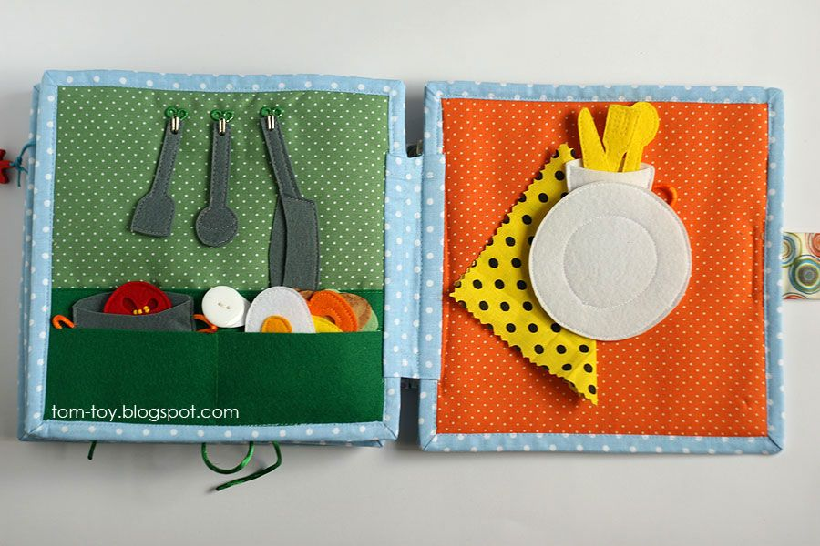 | Book Week- create a quiet book that can be shared with nursery children

