Goonhavern Primary School- Art
TOPIC: Fantastic Beasts and Where to Find Them- Caroline Walker (Cornish Artist)  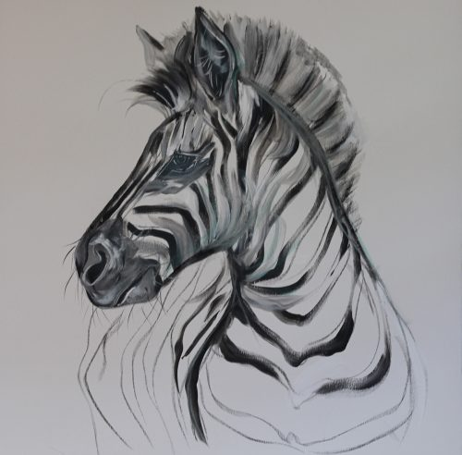 | YEAR: 6 | STRAND: Drawing, Painting, Mixed Media and Other Artists
School Values covered in this unit
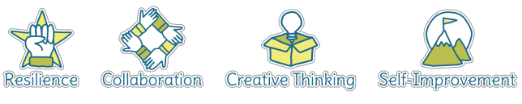
Five Ways to Wellbeing
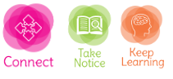

What should I know already? | What will I know by the end of the unit?
- How to collect ideas in a sketchbook  - How to use shading to show light and shadow effects  - I can use different materials to draw e.g. pencils, pastels, chalks  - I can mix colours confidently  - I can use an artist’s work to create my own replica  - I can express my ideas about the work of different artists  - I can use my study of other artists to develop my own ideas and work | Developing and Improving Ideas  - Review and revisit ideas in my sketchbook  - Use digital technology to help develop ideas  - To use a range of different media confidently  Painting  - To explore using a range of different brushes  - To create different effects  - To talk confidently about colours and to use natural and non-natural sources as inspiration for their colour palette  - To use colour to show mood  - To use a range of different media confidently  - To mix colours confidently and create my own colour palette  Drawing  - Use a variety of tools and select the most appropriate  - Depict movement and perspective in my drawings  - Use a range of techniques to add effects  Digital  - Use photographs in own work  Artists  - To discuss the work of different artists confidently  Evaluation  - Evaluate my work and the work of other artists using the language of art, craft and design

Vocabulary
abstract | Abstract art is art that does not attempt to represent an accurate depiction of a visual reality but instead use shapes, colours, forms and gestural marks to achieve its effect | medium | Refers to the different materials that can be used to create a piece of art
artist | A person who creates art as a profession or hobby | mixed media | A picture created using more than one medium
cold colours | Colours associated with rest, peace and sadness e.g. blue, purple and green | motif | A motif is a recurring fragment, theme or pattern that appears in a work of art
collage | A picture made from a variety of materials | pastels | Crayons made from powdered pigments
Craft makers | People who are skilled at making things by hand | pattern | A repeated decorative design
designers | People who plan the look of something before it is made | score | Marked lines where two pieces will be joined together
details | Minor decorative features | sculpt | To make a 3-D piece of art by casting, chiselling or constructing
evaluate | To make a judgement or have an opinion about | shape | The outside line of something
hot colours | Colours associated with energy, anger and heat e.g. yellow, red and orange | sketch | A quick, rough drawing
landscape | Landscape painting, the depiction of natural scenery in art. Landscape paintings may capture mountains, valleys, bodies of water, fields, forests, and coasts and may or may not include man-made structures as well as people | technique | A way of doing something
medium | Refers to the different materials that can be used to create a piece of art | tertiary colours | Colour made by mixing together two secondary colours
 |  | texture | The feel or appearance of a surface
 |  | tone | The lightness or darkness of a colour

Image/diagram that helps me to articulate my knowledge/understanding | Investigate!
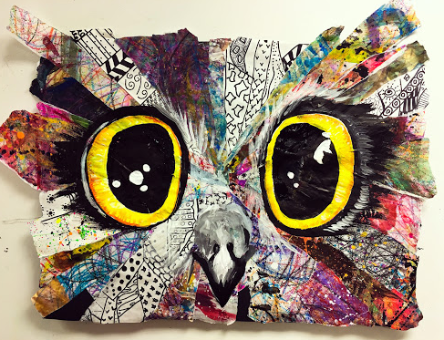 | https://www.tate.org.uk/art/teaching-resource/animals-art  http://elementaryartfun.blogspot.com/2017/11/collage-animals.html

