Goonhavern Primary School- Art
TOPIC: Hot and Cold (standalone skills unit)  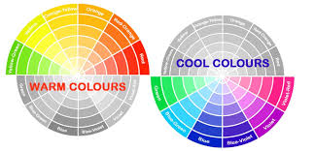 | YEAR: 4 | STRAND: Painting, Collage and Artists
School Values
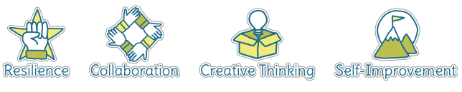
Five Ways to Wellbeing
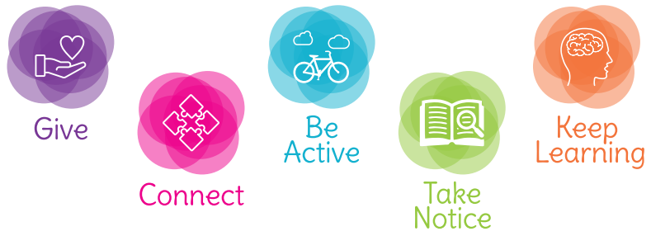

What should I know already? | What will I know by the end of the unit?
Painting  - Use paint and printing to create repeated patterns  - Mix a variety of colours and know which primary colours make secondary colours  - Print using a variety of materials, objects and techniques including layering  - Talk about the processes used to produce a simple print  Collage  - Copy images using a range of media and create own work  - Experiment with various textures, colours and patterns and create contrasting images  Artists  - Find out about the work of different artists, craft makers and designers  - Make links to own artwork  - Investigate different cultures | Painting  - Experiment with different effects and textures according to what they need for the task  - Mix colours to create own desired colours, using more specific colour language e.g. tint, tone, shade, hue  - Interpret music, stories, poems and other stimuli in artwork  - Research, create and refine a print using a variety of techniques  Collage  - Use collage as a means of collecting ideas and information and building a visual vocabulary  - Incorporate textiles into artwork  - Resist printing e.g. marbling and screen-printing  - Create surface patterns and textures in a variety of malleable materials  Work of other artists  - Find out about the work of different artists, craft makers and designers  - Make links to their own artwork  - Investigate different cultures  Evaluation  - Evaluate my work and that of other artists using the language of art, craft and design

Vocabulary
artist | A person who creates art as a profession or hobby | pattern | A repeated decorative design
cold colours | Colours associated with rest, peace and sadness e.g. blue, purple and green | printing | A technique used to create an image using a reusable carved stamp. There are different types of printing.
collage | A picture made from a variety of materials | score | Marked lines where two pieces will be joined together
colour wheel | A wheel of colours that shows the relationships between primary and secondary colours | sculpt | To make a 3-D piece of art by casting, chiselling or constructing
complementary colours | Colours that are opposite each other on the colour wheel | primary colours | Colours from which all other colours can be made by mixing
craft makers | People who are skilled at making things by hand | secondary colours | A colour made by mixing two secondary colours
designers | People who plan the look of something before it is made | shade | A colour mixed with black to make it darker
details | Minor decorative features | shape | The outside line of something
evaluate | To make a judgement or have an opinion about | sketch | A quick, rough drawing
frottage | The technique of taking a rubbing from a textured surface to use in a piece of artwork | technique | A way of doing something
hot colours | Colours associated with energy, anger and heat e.g. yellow, red and orange | texture | The feel or appearance of a surface
line | A long narrow mark or band | tone | The lightness or darkness of a colour
medium | Refers to the different material that can be used to create an artwork | warp | The threads or strips that remain still during the weaving process
mixed media | A picture created using more than one type of medium | weaving | A technique that involves interlacing materials like threads, paper or wood
observational drawings | A visual representation of something an artist sees | weft | The yarn or strips that are woven through the warp during weaving
palette | A thin board on which an artist lays and mixes colours
pastels | Crayons made from powdered pigments
pattern | A repeated decorative design

Image/diagram that helps me to articulate my knowledge/understanding | Investigate!
Kjell Nupen:  https://www.theguardian.com/artanddesign/2014/mar/21/kjell-nupen  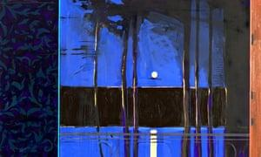  Pablo Picasso:  https://www.tate.org.uk/art/artists/pablo-picasso-1767  https://www.pablopicasso.org/  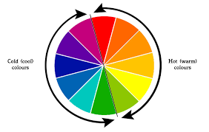 | Painting and Other Artists  - Analyse and evaluate the work of Kjell Nupen (Norwegian artist), with particular focus on form, tone and colour  - Children experiment mixing colours to form different shades, especially blue, trying to recreate ‘Nupen Blue’  - Use the ‘Nupen Blue’ colour to create a similar image showing a cold landscape  - Use clingfilm and red paint to create a hot, cracked landscape before exploring silhouettes of animals from hot climates  Collage and Other Artists  - Respond to collage work from Pablo Picasso. Learn the different techniques that he uses and his understanding of shape and how materials can complement or contrast each other  - Use images from Norwegian travel brochures, maps and magazines to create an image related to Norway e.g. the Northern Lights. DIGITAL- use images, created then printed, to incorporate into art work  - Use sketch books to map out a rough idea of what the collage will look like and material to be used. Evaluate ideas in sketchbooks.

